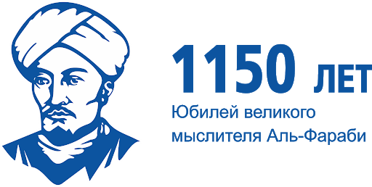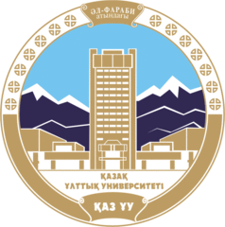

Dear colleagues!

Al-Farabi Kazakh National University informs you that an international scientific conference “The heritage of Abu Nasr al-Farabi and its role in the world civilization”, which is being held in commemoration of the 1150th anniversary of the Great Thinker.
The conference sets out to define the impact of legacy of the past on the emerging mindset of the era of global change, to mainstream the legacy of al-Farabi in the spiritual and moral development of the new era people, as well as spiritual and moral capacities of al-Farabi’s teaching within a context of global civilization.
Objectives: To discuss al-Farabi’s teaching of the formation of a morally perfect personality, of the virtuous city, of justice, equality, society, peace and happiness.
The conference will be held on March 26, 2020 in Almaty, in the Al-Farabi Kazakh National University.
The programme of the Conference features a plenary meeting and breakout sessions on the following subjects:
Session 1: “Al-Farabi and the modernity: philosophy of the human person. The path to happiness. A virtuous society” (Responsible person: Alikbayeva M.B. Marzhan.Alikbaeva@kaznu.kz, 87074297879)

Session 2: “Al-Farabi Legacy in Eastern Countries” (Responsible person: Dzhakubayeva S.T. Saltanat.Dzhakubayeva@kaznu.kz, 87477084060)

Session 3: “Al-Farabi Legacy and its role in Intercultural Communication” (Responsible person: Zhekenov D.K. Duman.Zhekenov@kaznu.kz, 87078307457)

Working languages of the conference: Kazakh, Russian and English.
The organizing committee requests to confirm your participation in the conference and send the topic of your report to the above-mentioned e-mails until March 13, 2020.
Venue: “Al-Farabi” scientific library.
The organizing committee: Republic of Kazakhstan, 050040, Almaty, Al-Farabi avenue, 71, Department of science and innovation. Те phone number: +7 (727) 377-33-30, ex.16-62, mob. 87471698469. Slyamova Elmira Serikovna, Elmyra.Sliyamova@kaznu.kz
Application form

1. | Full name
2. | City
3. | Place of work, position
4. | Degree, academic rank
5. | Mobile phone number
6. | E-mail
7. | Topic of the report
8. | Breakout session

